Nithin S
221IT085

IT302 Lab Assignment 3

Q1. Using standard normal distribution, write a R/Python code for any normal
random variable, to the probability it is
(a) Within 1 standard deviation of its mean.
(b)Within 2 standard deviations of its mean.
(c) Within 3 standard deviations of its mean.

Code

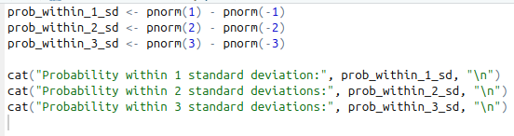
Output

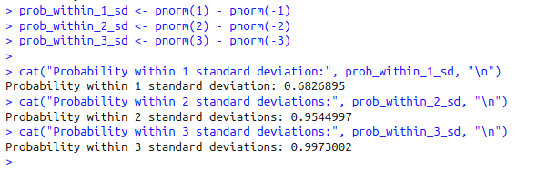

Q2. The length of a long-distance telephone calls follows normal distribution with mean of 20 minutes and standard deviation of 5 minutes. Suppose a sample of 60 telephone calls is used to reflect on the population of all longdistance calls. Write a R/Python code to find the following. (a) About how many calls are between 16 and 18 minutes? (b) How many minutes would include within 3 standard deviations of its mean? (c) A 12-minute call would be how many standard deviations below the mean?

Code

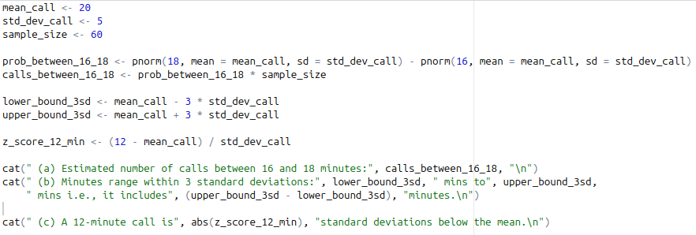
Output

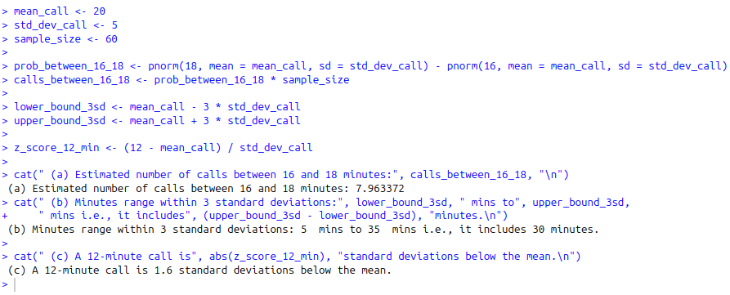

Q3. Use Monte Carlo simulations in R/Python to simulate the following
scenario. It’s my 28th birthday, and my friends bought me a cake with 28
candles on it. I make a wish and try to blow them out. Every time, I blow
out a random number of candles between 1 and the number that remains,
including one and that other number. How many times, on average, do I
blow before all the candles are extinguished?

Code

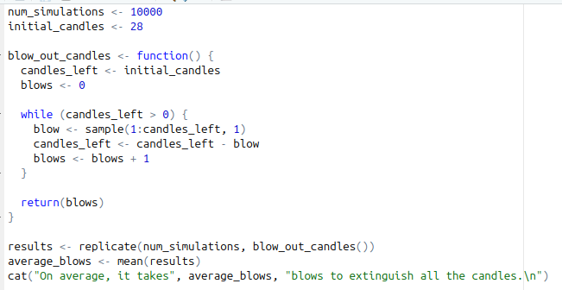

Output

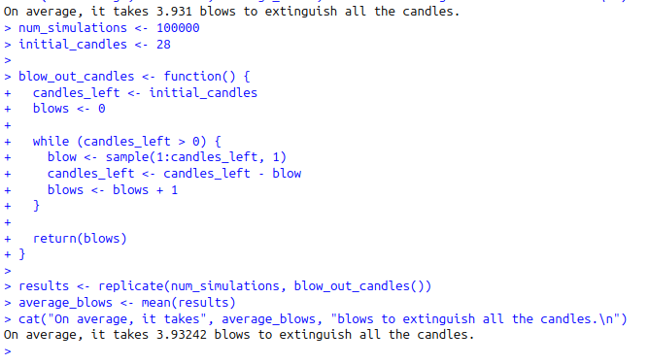

Q4. Use Monte Carlo simulations in R/Python to simulate the following
scenario. Two teams, say Cavs and Warriors, are playing a seven-game
championship series. The first to win four games, therefore, win the series.
The teams are equally good, so they each have a 50-50 chance of winning
each game. If the Cavs lose the first game, what is the probability that they
win the series?

Code
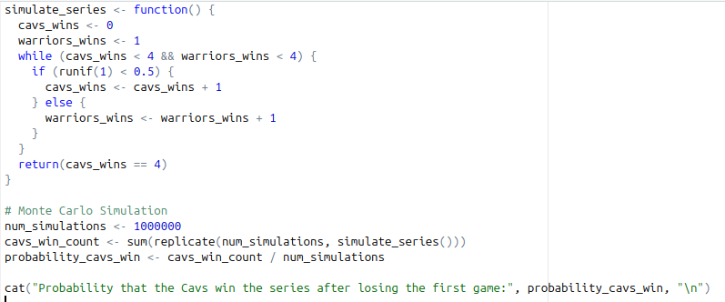

Output

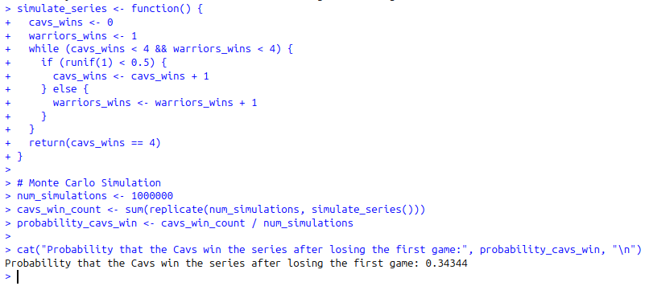

Q5. Consider the cars dataset in R. This data frame has 50 observations on two variables: speed and distance. For speed data using R/Python, find
(a) Mean, variance, standard deviation.
(b) Median, mode, standard error.
(c) Draw the histogram.

Code

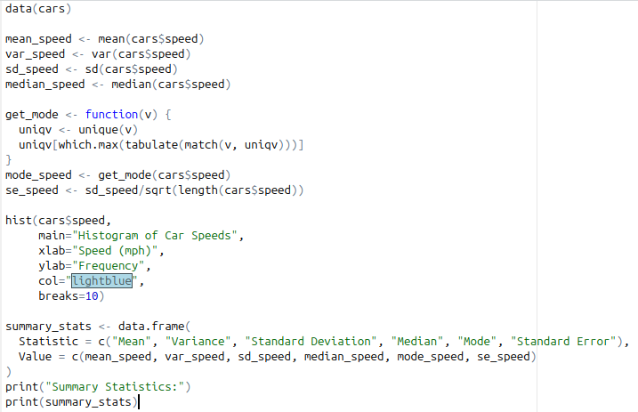

Output

